1. Prompt for amount, interest rate and no. of years and calculate simple interest.
Scripts:
<html>
<head>
<script>
var amount, interest, time;
var result;
amount = parseInt(prompt("Please enter Principle amount:"));
interest = parseInt(prompt("Please enter Interest Rate :"));
time = parseInt(prompt("Please enter years:"));

result = (amount*time*interest)/100;
document.write("The Interest will be paid after: "+time+" years : Rs."+result+" <br> The total amount will be paid :"+(amount+result));
</script>
</head>
</html>
Output:
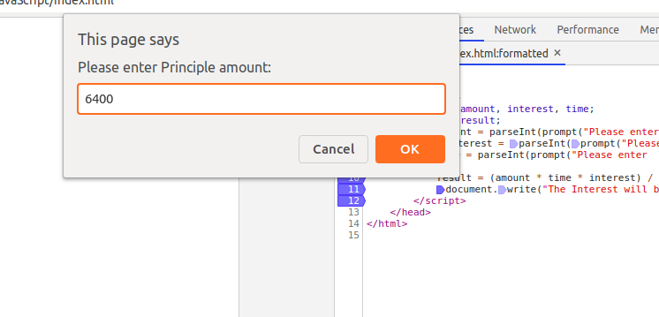

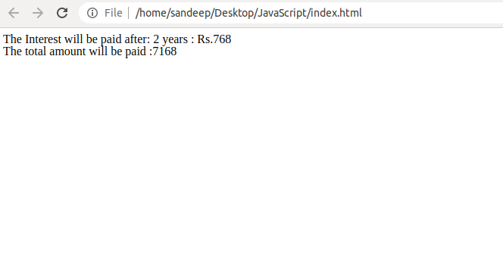
2. is palindrome string
Scripts
<html>
<head>
<script>
var word = " bob ";
var reg = /\s/g;
var w = word.toLowerCase().replace(reg,'');
var reverse = w.split('').reverse().join('');
if(w == reverse)
{
document.write("It is a palindrome ");
}
else
{
document.write("It is not a palindrome ");
}
</script>
</head>
</html>

Output:
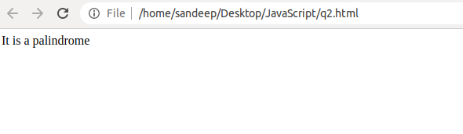

Q3. Area of circle
Scripts
<html>
<head>
<script>
var radius = window.prompt("Please enter a radius of a circle");
function circleArea(radius){
return 3.14*radius*radius;
}
var area = circleArea(radius);
document.write("<br> Area of Circle : "+area);
</script>
</head>
</html>

Output:
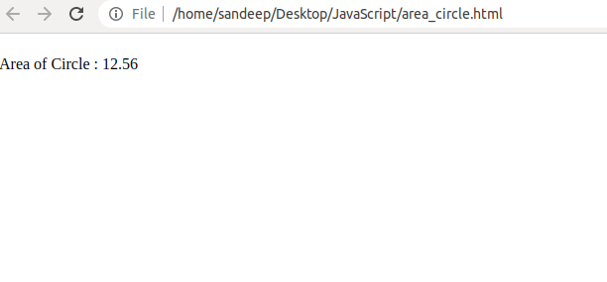
Q4. Copy information of one object to another and log it to console.
Scripts:
<html>
<head>
<script>
var friends = {name:"Micky", Age:"22", graduation:"MCA"};
document.write("check your console log ................<br><br>");
var copy = friends;
console.log(copy.name);
document.write("Done ........... ");
</script>
</head>
</html>

Output:
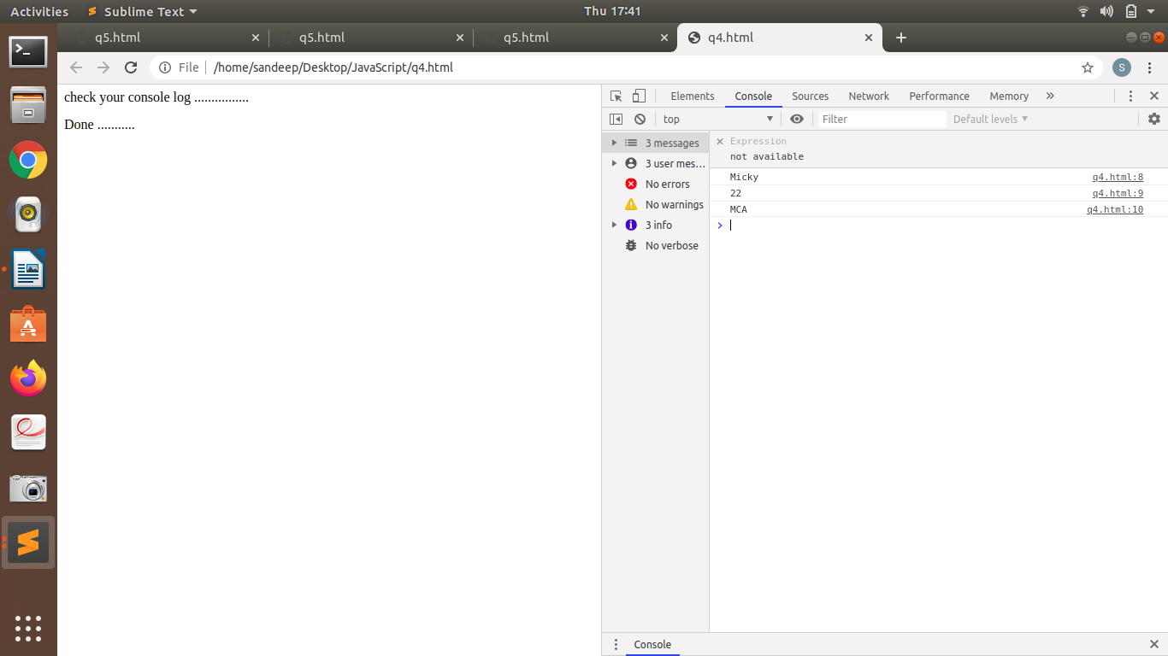

Q5. create a list of objects of Employee with info as follow :
  - Name, age, salary ,DOB
  - filter all employees with salary greater than 5000
  - group employee on the basis of their age
  - fetch employees with salary less than 1000 and age greater than 20. Then give them an increment 5 times their salary.

Script:
<html>
<head>
</head>
<body>

<button onclick="printMe()">Print list</button>

<button onclick="filter_me()">Salary less than 5000</button>
<button onclick="group_me()">Group Me</button>
<button onclick="increment_salary()">Increment Salary</button>

<script>
var i;
var Employee = [
{
name: "Sandeep",
Age: 22,
Salary: 15500,
DOB: '22-Dec-1996'
},
{
name: "Neha",
Age: 23,
Salary: 15500,
DOB: '31-Mar-1995'
},
{
name: "Akshita",
Age: 34,
Salary: 15500,
DOB: '22-Dec-1988'
},
{
name: "Shreya",
Age: 24,
Salary: 2500,
DOB: '22-Dec-1988'
}
, {
name: "Anita",
Age: 24,
Salary: 3500,
DOB: '22-Dec-1988'
}
, {
name: "Vinay",
Age: 22,
Salary: 100,
DOB: '22-Dec-1988'
}
, {
name: "Nisha",
Age: 21,
Salary: 800,
DOB: '22-Dec-1988'
}
];

function printMe(){
document.write(" <h2>List :</h2> <br>");
var word;
for(i=0;i< Employee.length;i++)
{

document.write(" <h3> Name : "+Employee[i].name+" | Age : "+Employee[i].Age+" | DOB : "+Employee[i].DOB+" | Salary : "+Employee[i].Salary+"</h3>");
}

}

function filter_me()
{
document.write(" <h2>The employees having salary greater than Rs. 5000:</h2> <br>");

//filtering
var filtered = Employee.filter(function(a) {
return a.Salary > 5000;
})

for(i=0;i< filtered.length;i++)
{
document.write(" <h3> Name : "+filtered[i].name+" | Age : "+filtered[i].Age+" | DOB : "+filtered[i].DOB+"</h3>")

}

/* Alternate way

for(i=0;i< Employee.length;i++)
{
if(Employee[i].Salary < 5000)
{
document.write(" <h3> Name : "+Employee[i].name+" | Age : "+Employee[i].Age+" | DOB : "+Employee[i].DOB+"</h3>")

}
}*/

}

function group_me()
{
var GroupMe = Employee;

// grouping
document.write(" <h2>Sorting ................. </h2> ");
GroupMe.sort(function(a, b){
return a.Age - b.Age;
});

let groopedData = GroupMe.reduce((r, a) => {
r[a.Age] = [...r[a.Age] || [], a];
return r;
}, {});
console.log(groopedData)
}

function increment_salary()
{
// Fetch employees having salary less than 5000 as well as age more than 20, and increment their by 5 times
document.write(" <h2>Before Incrementing </h2> ");

for(i=0;i< Employee.length;i++)
{

document.write("<h3> Name : "+Employee[i].name+" | Age : "+Employee[i].Age+" | DOB : "+Employee[i].Salary+"</h3>");
}

document.write(" <h2>The employees having salary less than Rs. 1000 and age more than 20 years will get incremented salary from now :</h2> ");
for(i=0;i< Employee.length;i++)
{
if(Employee[i].Salary < 1000 && Employee[i].Age > 20 )
{

Employee[i].Salary = Employee[i].Salary*5 ;

}

}

for(i=0;i< Employee.length;i++)
{

document.write(" <h3> Name : "+Employee[i].name+" | Age : "+Employee[i].Age+" | DOB : "+Employee[i].Salary+"</h3>");
}

}

</script>

</body>
</html>

Output:

i)
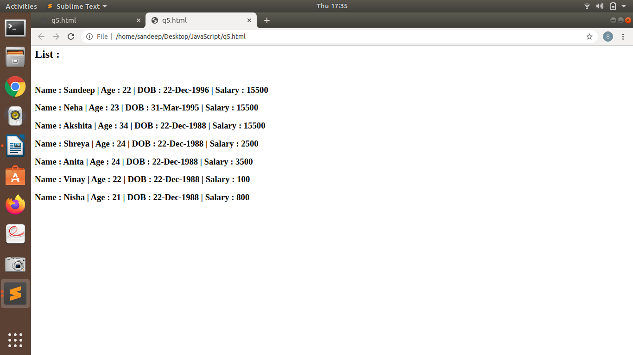

ii)

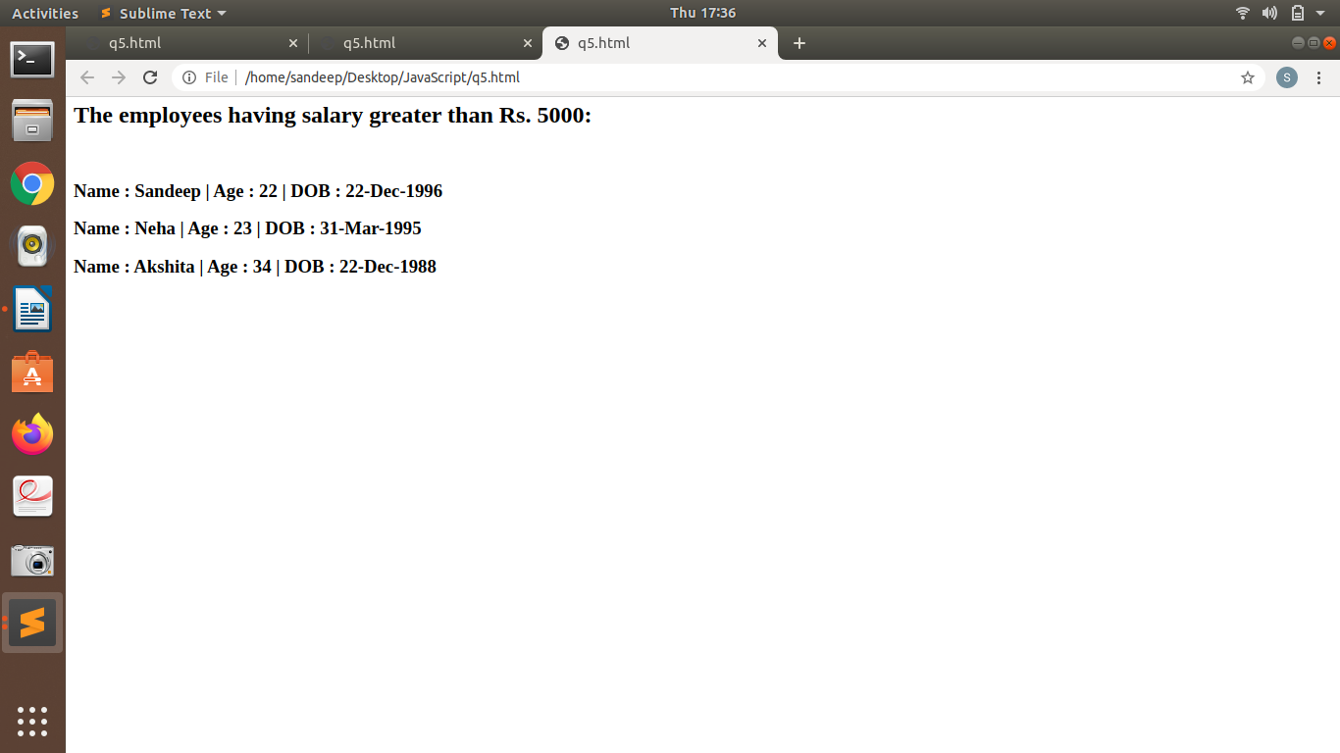

iii)
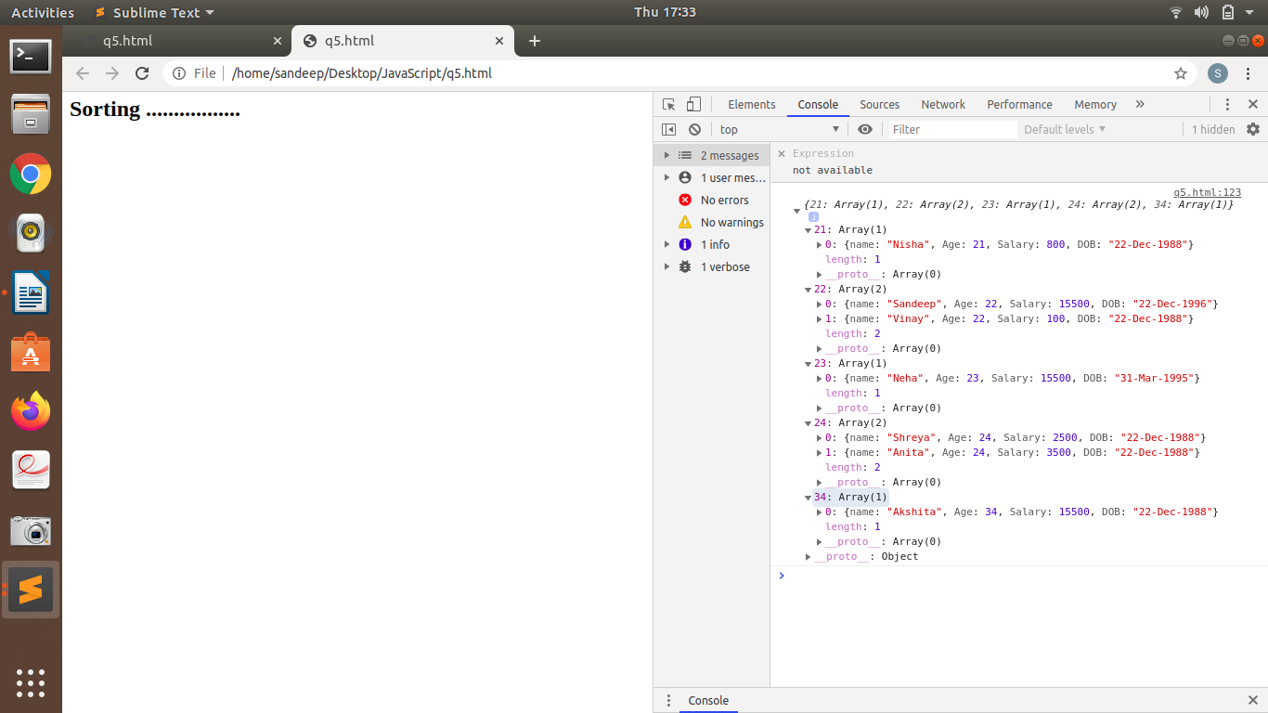
iv)

